Development Report

Contents

1. Functional Requirements for the Staff Directory Mobile Application: 3

2. Technical Requiremnts: 3

2.1 Login Page: 3

2.2 Directory Page: 4

2.3 Employee Details Page: 7

2.4 Update Page: 8

3. Initialising GitHub: 10

1. Functional Requirements for the Staff Directory Mobile Application:

* To display list of all company staff profiles
* To display staff profile details when a staff member is selected
* Add or Update staff profiles
* Run on Android operating system
* Support Mobile phones and Tablet

1. Technical Requirements:
   1. 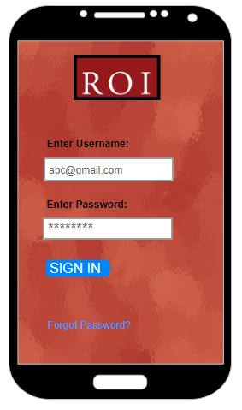Login Page:
2. **Functions:** This page is primarily responsible for authenticating users before granting them access to the system.
3. **Actions:** Users can input their username and password in the provided text fields. Users can also submit their credentials for verification and navigate to recovery page if they have forgotten their password.
4. **Components:** Text fields where users input their username and password. Button that users click to submit their login credentials. A hyperlink that redirects users to the password recovery page.
5. **Events:** A “Button Clicked” event which triggers when the user clicks the login button. "Forgot Password Clicked" event which triggers when the user clicks the "Forgot Password?” link**.**
6. **Inputs:** The user's username and password.
7. **Outputs**: Authentication result (success or failure message).
   1. Directory Page:

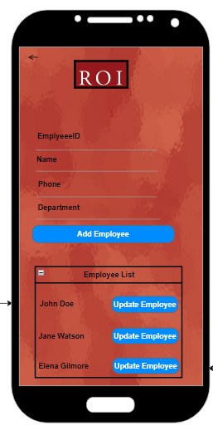

1. **Functions:**

* **Display Directory**: This page is responsible for presenting a list or directory of employees.
* **Add New Employees**: The page allows for the addition of new employees to the directory.
* **Update Information**: The page provides functionality to update existing employee information.
* **View Detailed Information**: Users can view more detailed information about an employee by selecting their name from the directory list.

1. **Actions:**

* **View Directory**: End-users can view a list of items or entities displayed on the directory.
* **Select Employee to View Details**: Users can select an employee's name to view more detailed information about that employee.
* **Update Employee Information**: Users can initiate an update to an employee's information by clicking the "Update Employee" button.
* **Add New Employee**: Users can add a new employee's information by clicking the "Add Employee" button.
* **Navigate Back**: Users can return to the previous page.

1. **Components:**

* **List/Directory Display**: A component that displays the list of items or entities. This could be a table, grid, or another form of structured list, depending on the UI design.
* **Individual Employee Selection**: Each employee's name could be a clickable element that, when selected, displays more detailed information about that employee.
* **"Update Employee" Button**: A button that, when clicked, allows users to update information for employees.
* **"Add Employee" Button**: A button that, when clicked, opens a form or another page where users can input information for a new employee.
* **"Back" Button**: A button that allows users to return to the previous page.

1. **Events:**

* **"Employee Selected"**: Occurs when a user clicks or selects an employee's name, displaying detailed information about the employee.
* **"Update Employee Clicked"**: Occurs when a user clicks the "Update Employee" button, likely opening a form or another page where they can alter employee information.
* **"Add Employee Clicked"**: Triggers when a user clicks the "Add Employee" button, likely initiating a process where they can enter new employee information.
* **"Back Button Clicked"**: Occurs when a user clicks the "Back" button, returning them to the previous page.

1. **Inputs/Outputs:**

* **Input**: User interactions with the "Update Employee," "Add Employee," and "Back" buttons, as well as selecting an employee's name. If adding or updating employee information involves input fields, those would also constitute inputs.
* **Output**: The list of items or entities displayed on the directory page. Detailed employee information viewable upon selection. Feedback on the successful addition or updating of employee information, as well as any error messages, would also be outputs.
  1. Employee Details Page:

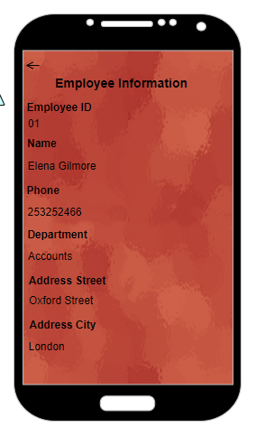

**1. Functions:**

* Display detailed information about a selected employee.
* Navigation back to the directory page.

**2. Actions:**

* View detailed employee information.
* Navigate back to the directory page.

**3. Components:**

* Employee detail fields (fields displaying various employee information).
* Back button (to navigate back to the directory page).

**4. Events:**

* Back button clicked.

**5. Inputs/Outputs:**

* **Input:** Detailed data of the selected employee (from a database or an API).
* **Output:** Displayed employee details.
  1. Update Page:

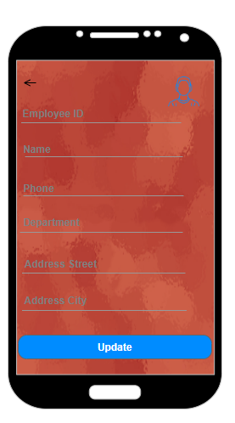

**1. Functions:**

* Allow users to modify existing employee details.
* Update and save the employee details when the "Update" button is clicked.
* Navigate back to the Directory Page without making changes.

**2. Actions:**

* Edit employee details in the provided fields.
* Update and save the modified details using the "Update" button.
* Navigate back to the Directory Page using the "Back" button.

**3. Components:**

* Input fields for updating employee details.
* "Update" button to save the changes.
* "Back" button to navigate back to the Directory Page.

**4. Events:**

* Input fields modified.
* "Update" button clicked.
* "Back" button clicked.

**4. Inputs/Outputs:**

* **Input:** Existing employee details to populate the input fields (from an SQLite database).
* **Output:**
* Updated employee details saved when the "Update" button is clicked.
* Navigation back to the Directory Page when the "Back" button is clicked.

1. Initialising GitHub:

* 1. Staging All Files for Commit:

* 1. Committing the changes:

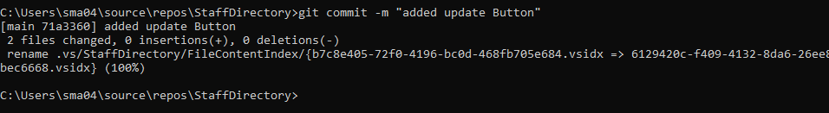

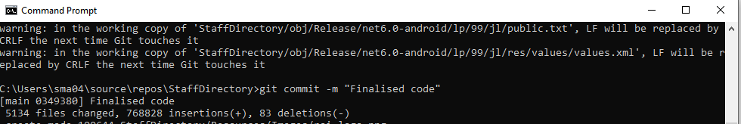

* 1. Pushing the file to Remote Repository:

